Name: | Bodhisatya Ghosh
Class: | CSE DS
Batch: | B
UID: | 2021700026
Experiment: | 5

Aim: To install apache server on system

Step 1: Update system
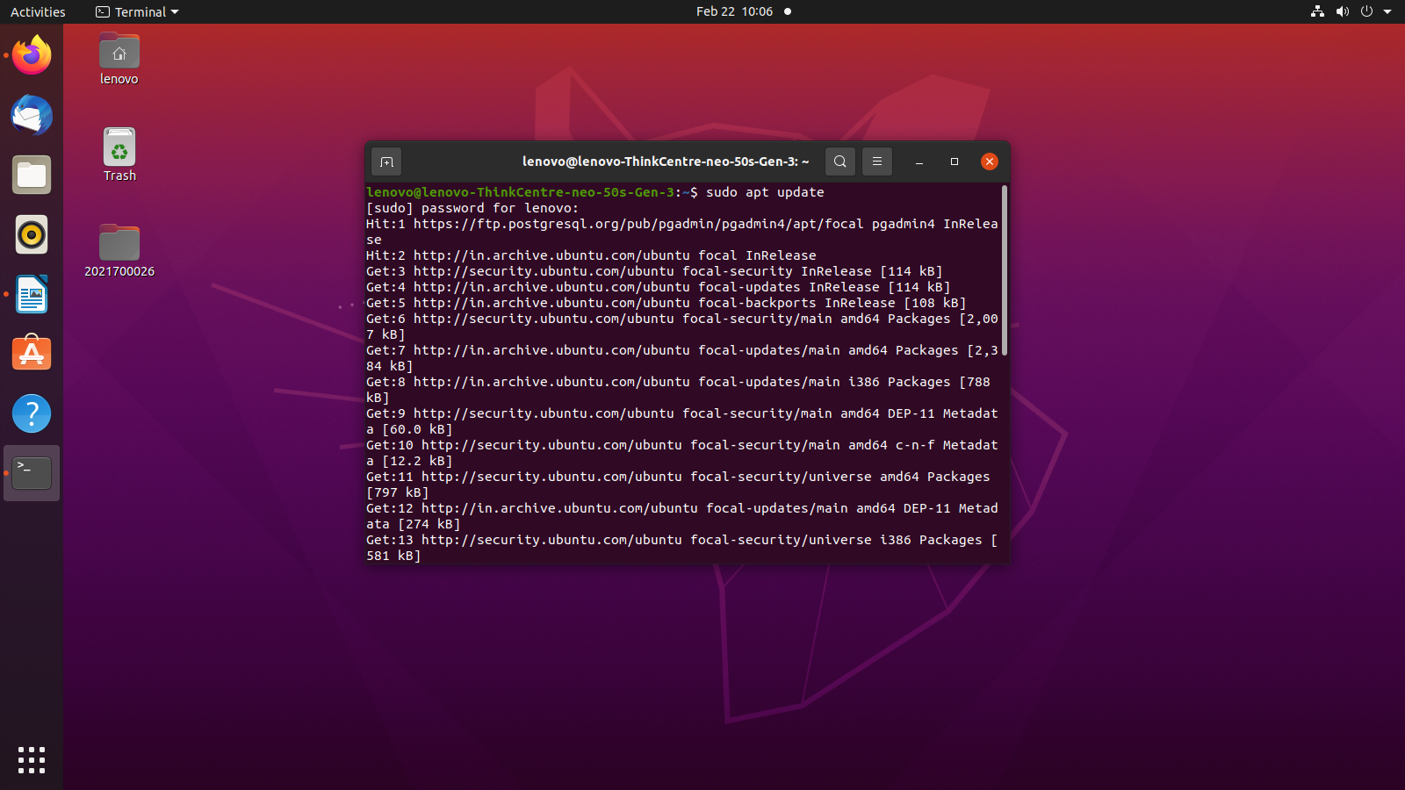
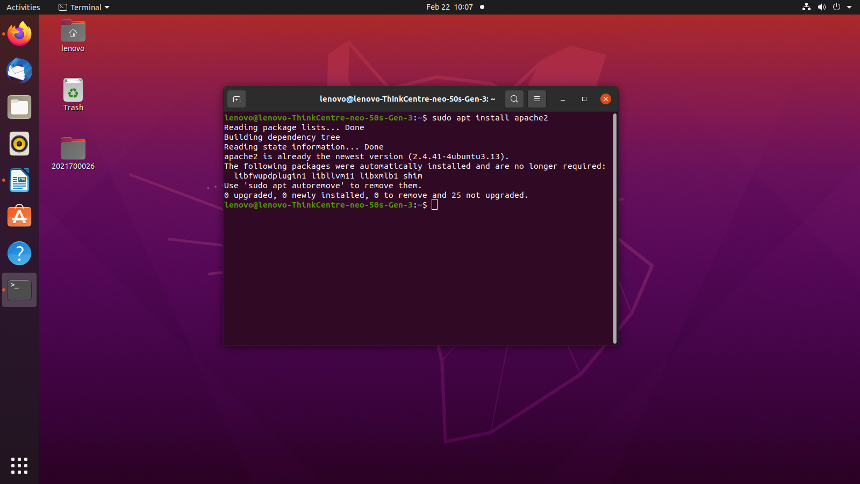
Step 2: Install Apache on system
Step 3: Start apache2 services and check status
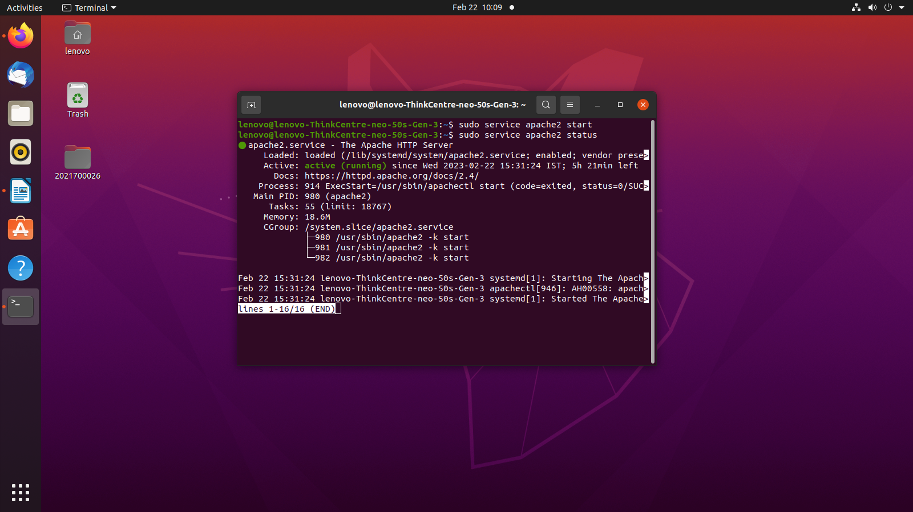
Step 4: Replace index.html file at /var/www/html directory with your webpage
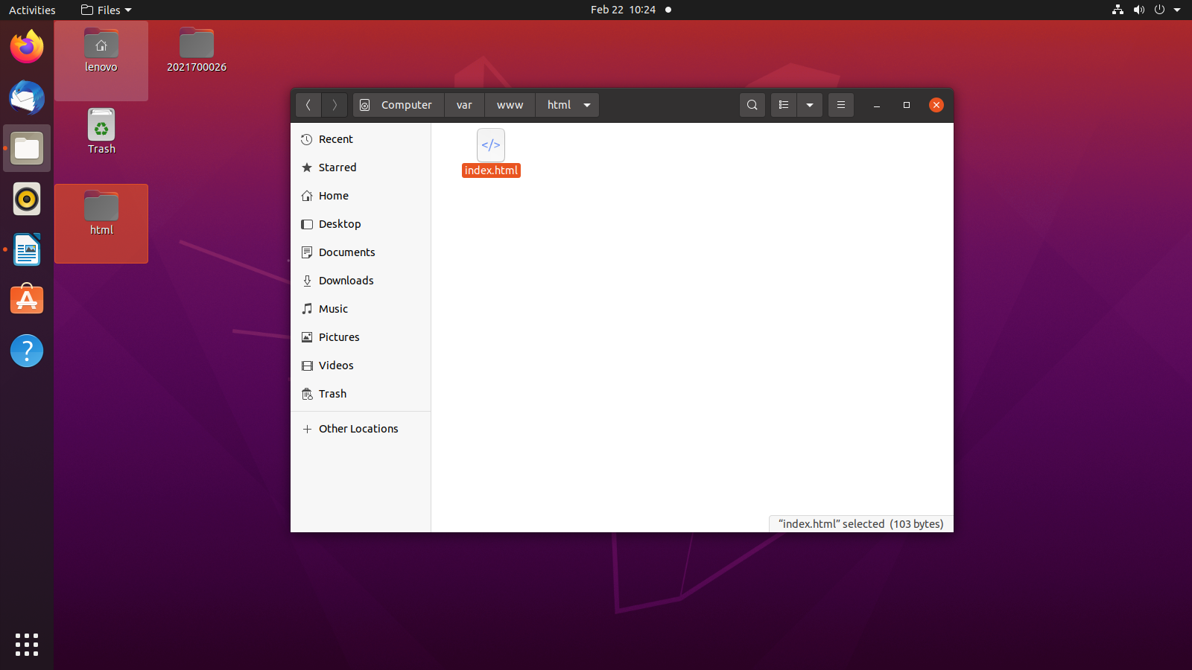
Step 5: Web page on ip address of device
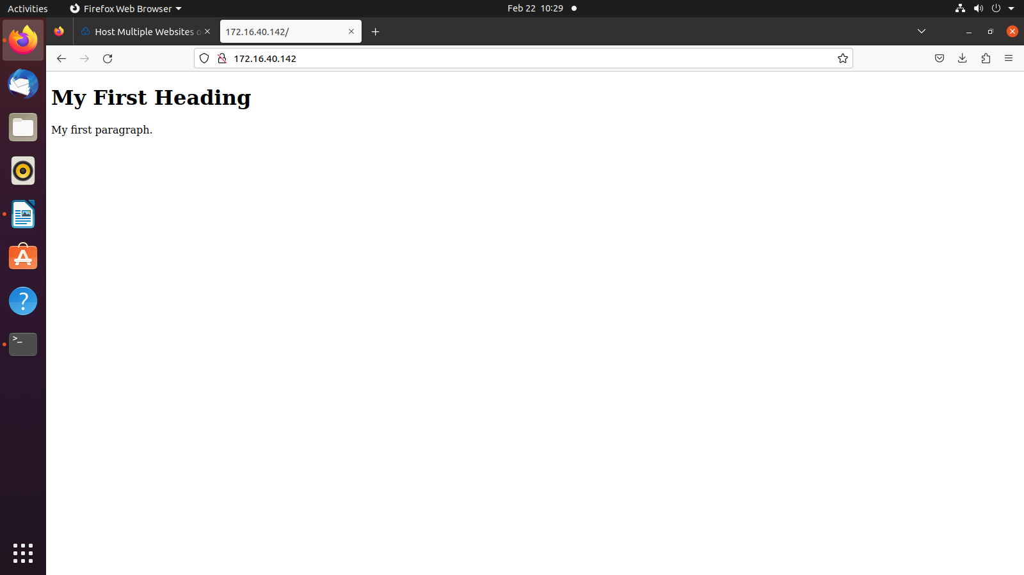

To create multiple domains on virtual hosts

Step 1: Create different directories for all virtual hosts you want to create
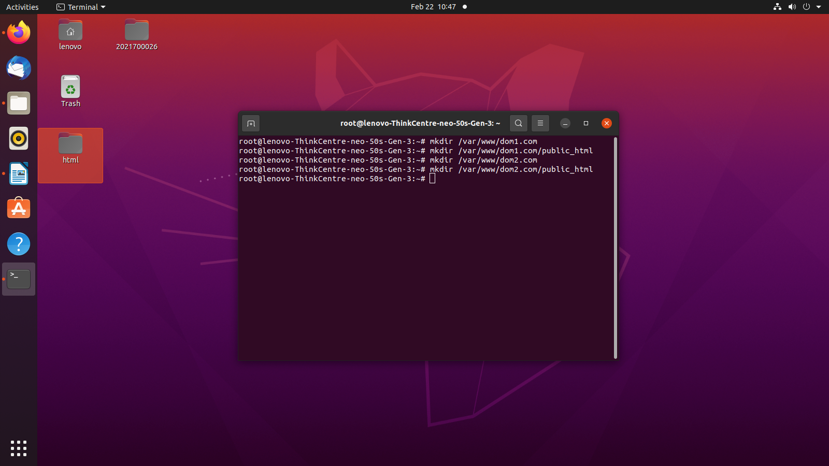
Step 2: Move index.html for respective sites to their public_html directories.
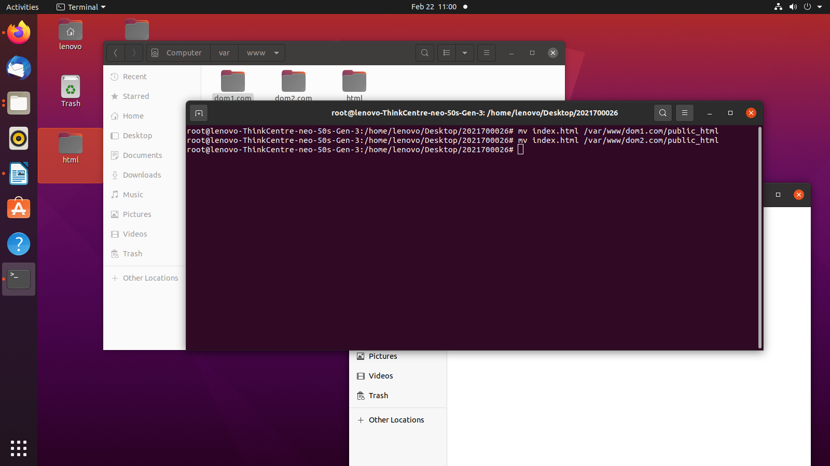
Step 3: Create new virtual host file in /etc/apache2 directory
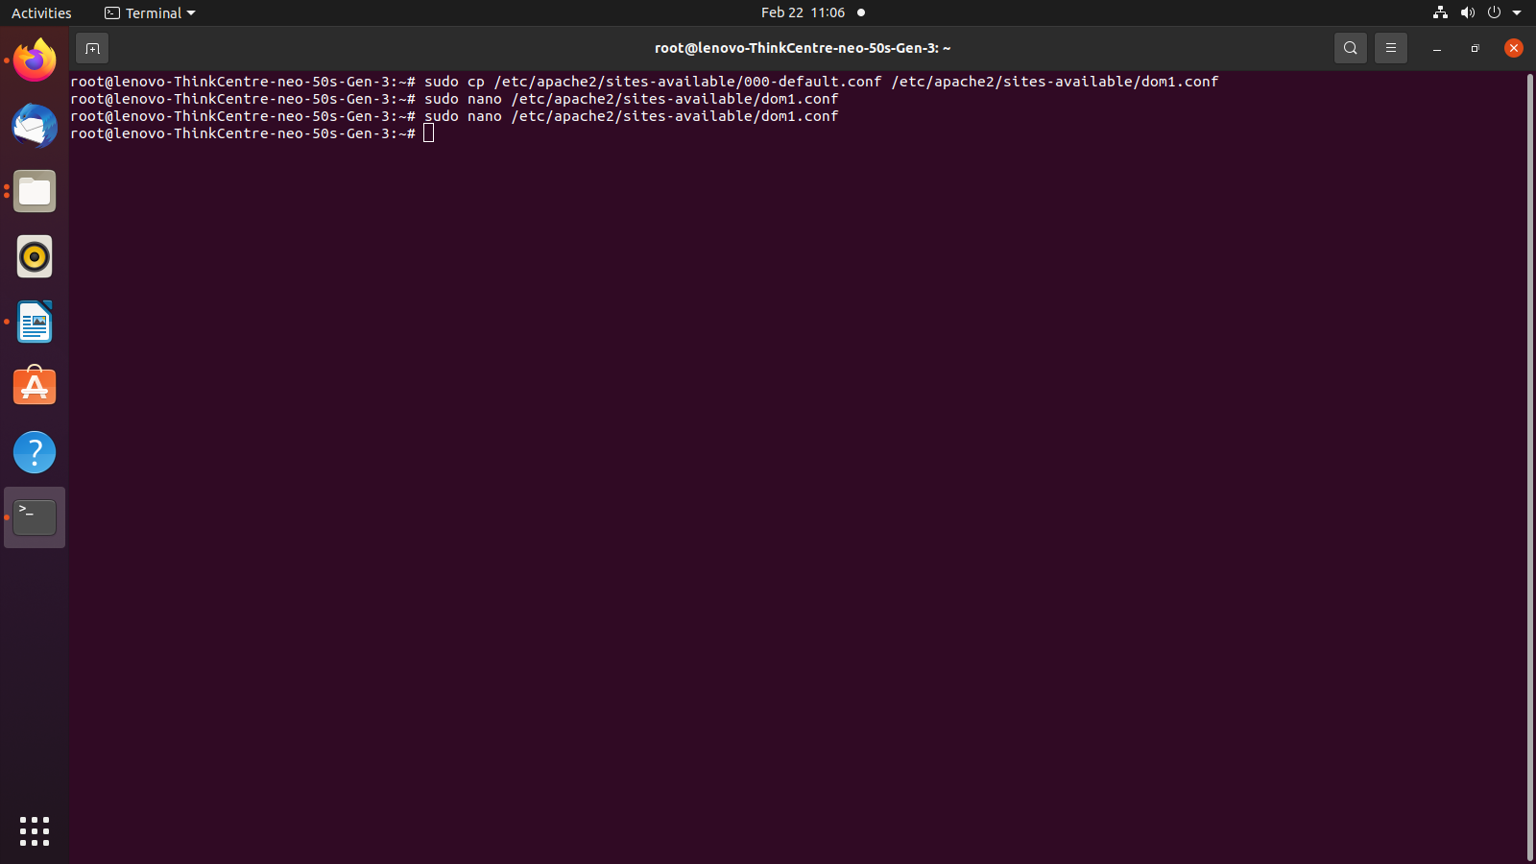
Step 4: In virtual host file, change server admin email ID to email ID you want to use as admin
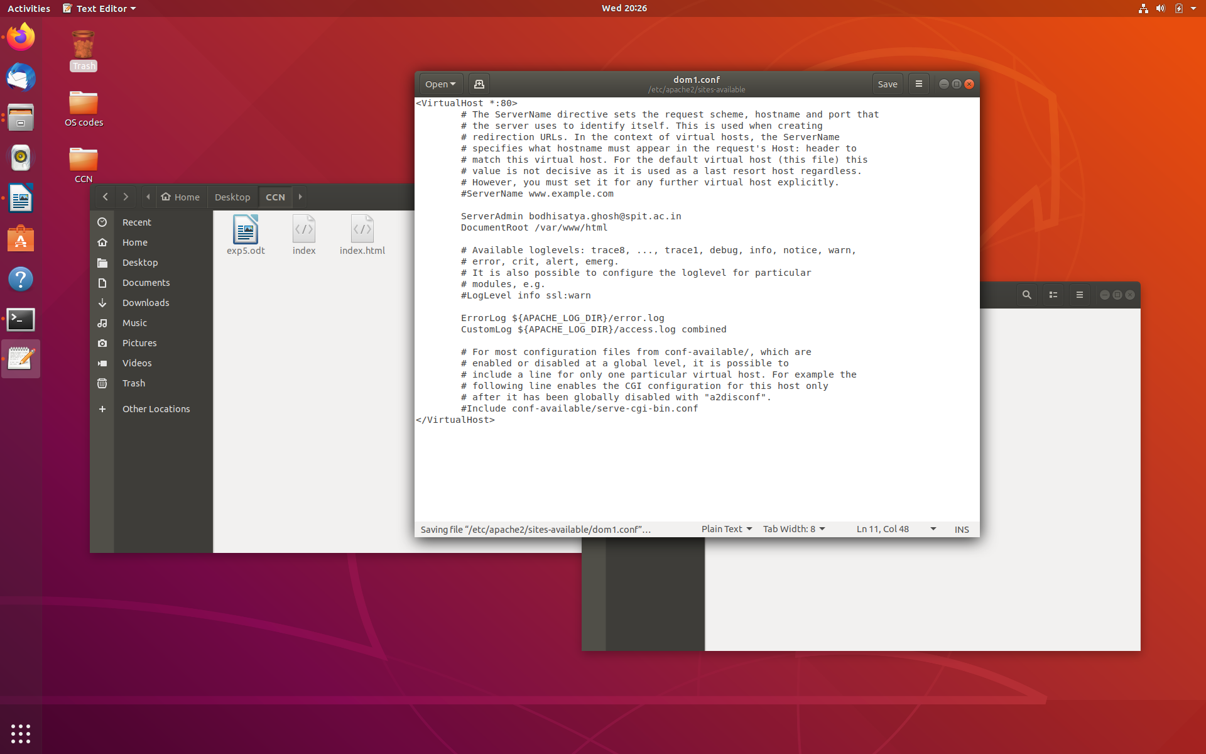
Step 5: Add ServerName and ServerAlias to this file as well along with path to document root
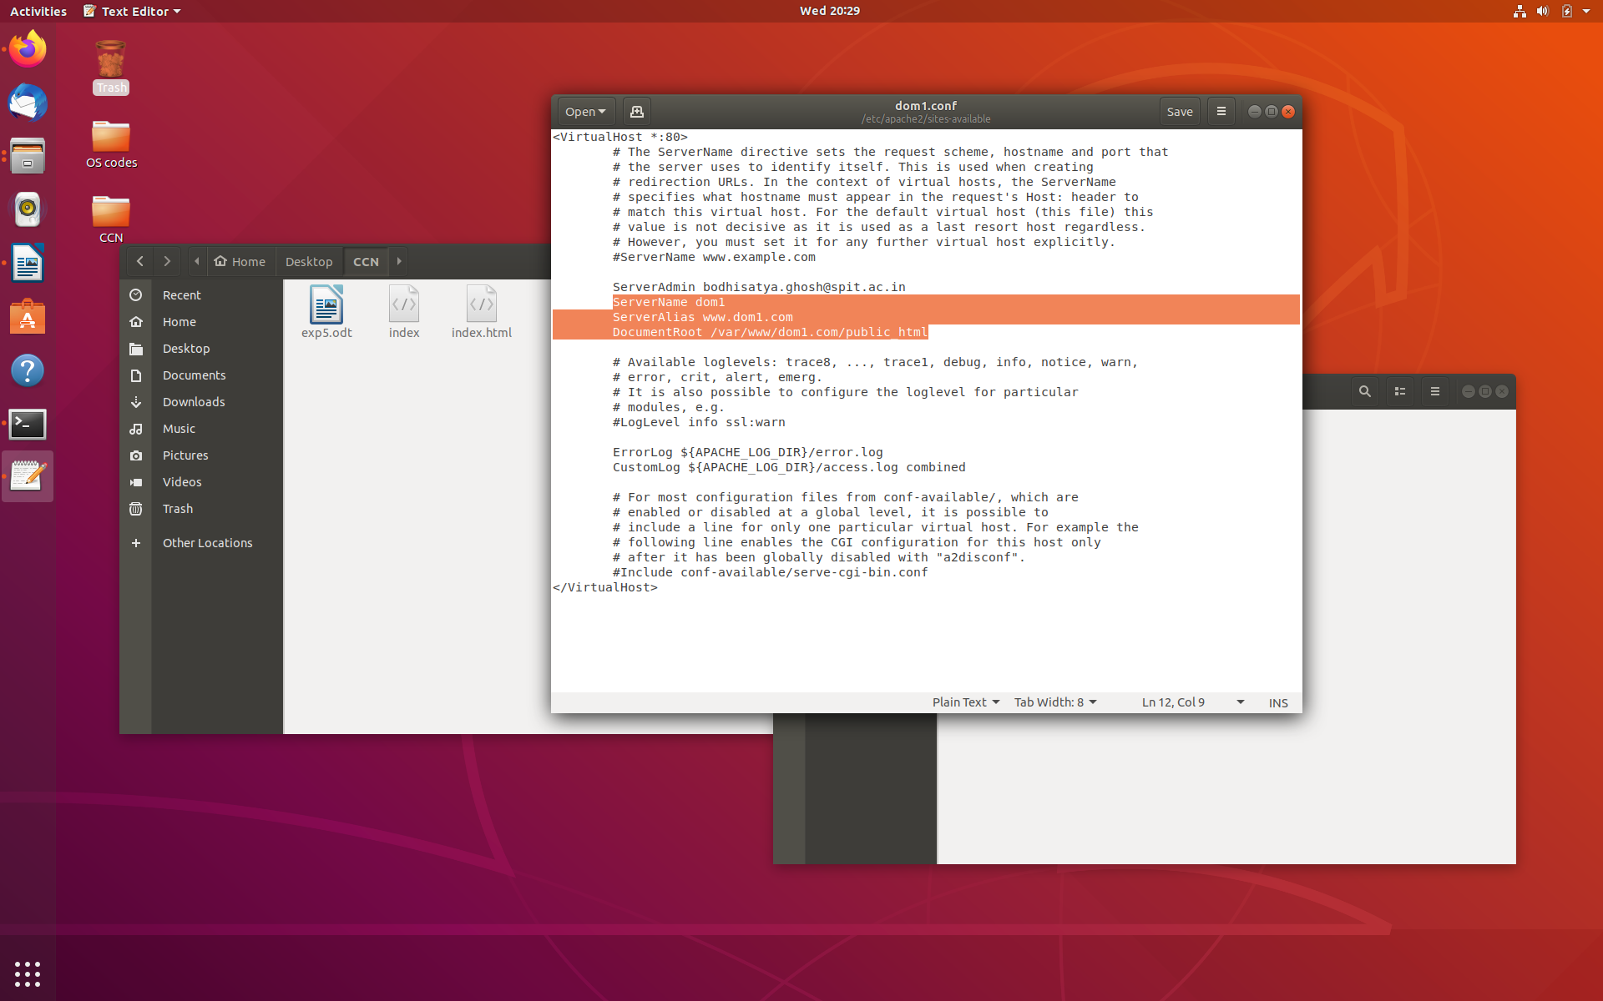
Step 6: Enable new dom1 site and disable 0000-deafult.conf site
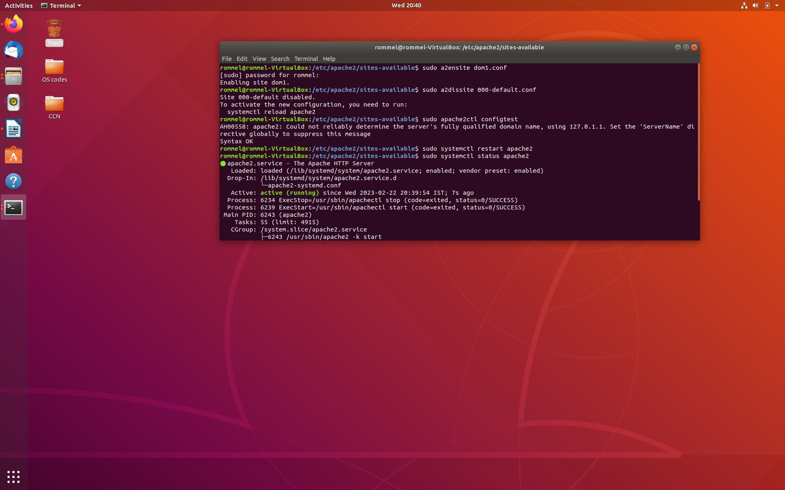
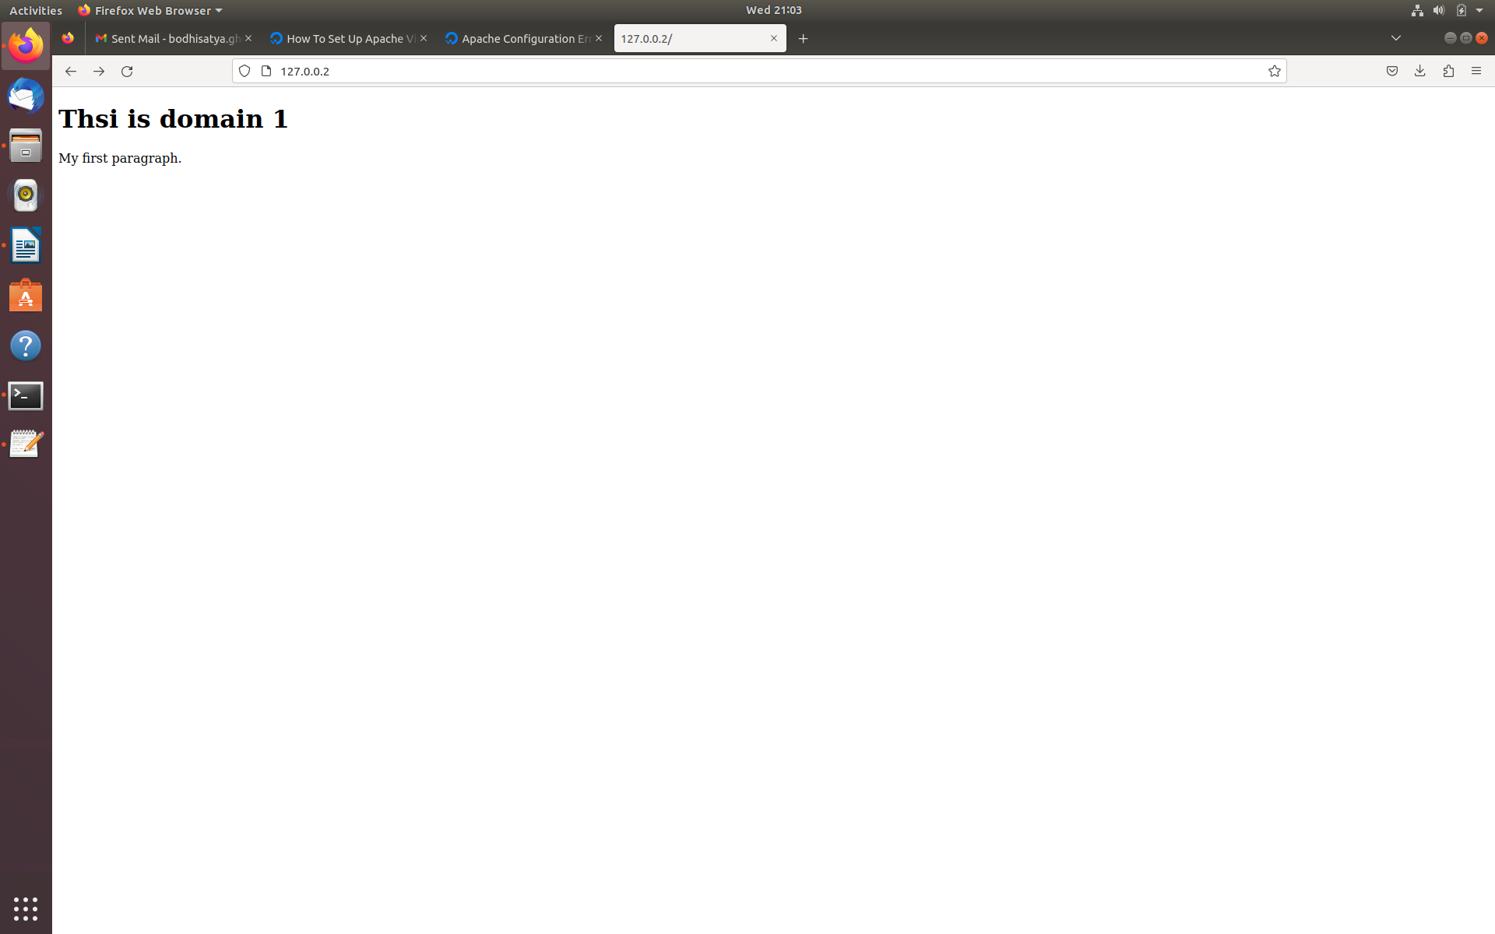
Step 7: Go to IP address specified by local host file
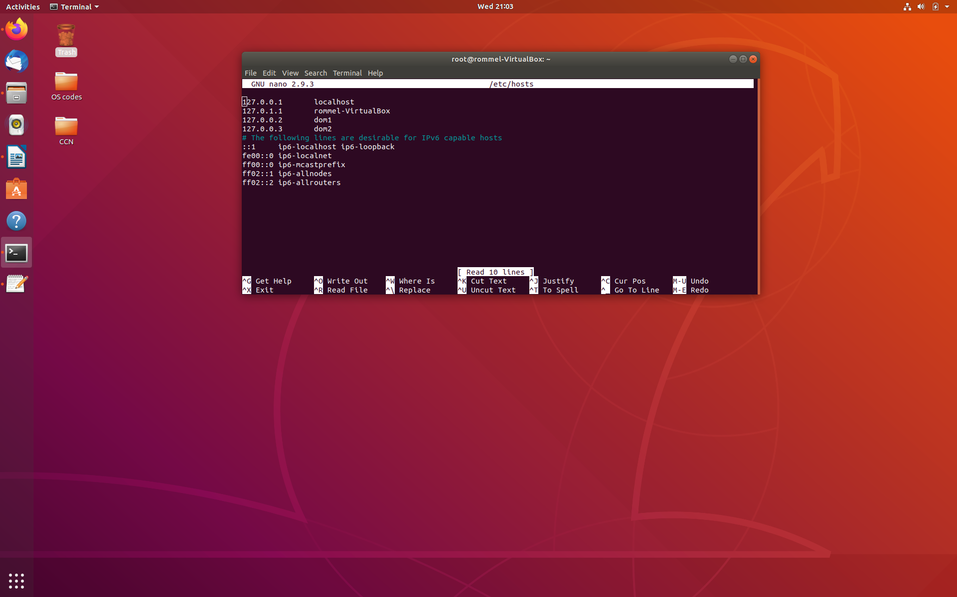
------------------------------------------------------------------------------------------------------------------------

Conclusion: In this experiment I have learnt how to use Apache to create a website. I have also learnt how to use multiple domains from virtual host machines on a single device.

